Email scripts

Subject: Top ranked benefit to recruit, retain and reward employees

Dear [sponsor name]

Are your employees or job candidates asking about an RRSP plan?

We’re seeing many employers successfully achieve their employee wellness priorities, while solving recruiting and retention challenges with a workplace retirement plan.

· 84% of Canadian businesses expect to face hiring challenges in the next year
· 78% of candidates say retirement benefits are a critical factor in deciding to take a job
· Providing a retirement plan can increase job tenure by up to 6 years

A great retirement benefit doesn’t have to be expensive or complicated. [Brokerage name] has partnered with Common Wealth to provide an award-winning, digital group RRSP/TFSA built for growing businesses.

Top features:

· Professionally managed, streamlined investments at a low fee
· Employees save on their taxes by contributing straight from their paycheque
· Flexible contribution levels for employers, taking only a few minutes per month to administer

I have attached a short PDF with the latest research on how retirement benefits can boost retention and recruitment.

If this resonates, I’d love to set up a time to discuss further.

Regards,

[advisor name]

Recruiting

Subject: The top benefit job candidates look for

Hello [sponsor name],

If you’re struggling to find qualified staff to fill open positions, you’re not alone.

· 84% of Canadian businesses expect to face hiring challenges in the next year
· 52% of SMBs have had at least one position open for four months or more
· 78% of candidates say retirement benefits are a critical factor in deciding to take a job

Strategic employers are introducing retirement plans to help with recruiting

Staff shortages and increased stress brought on by the pandemic have shifted HR budgets from social events and stocked snack cabinets to compensation packages that are more aligned with wellness priorities. Retirement benefits not only help employees feel more confident about their financial future, but they’re also helping employers attract top talent.

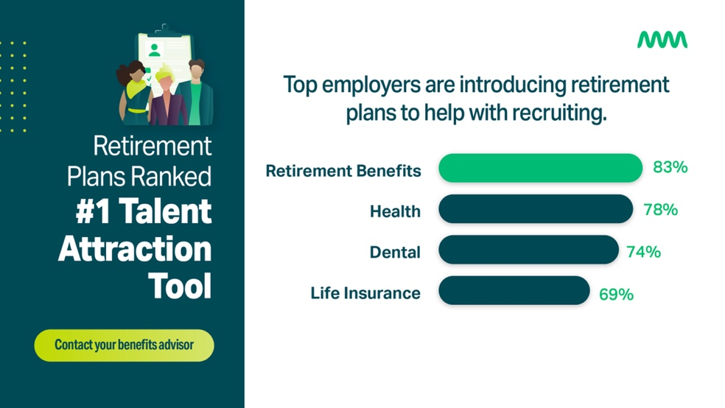

A great retirement plan doesn’t have to be expensive or complicated. [Brokerage name] has partnered with Common Wealth to provide an award-winning, digital group RRSP/TFSA built for growing businesses.

I’d love to set up a time to discuss further.

Regards,

[advisor name]

Retention

Subject: How to keep employees in a hot talent market

Hello [sponsor name],

A hot labour market is forcing many Canadian businesses to review their compensation and benefits plans to prevent staff from leaving. Since the pandemic, 53% of Canadian employers are experiencing higher employee turnover, and 66% expect the problem to persist or get worse.

Employers rank retirement benefits as a top retention tool
Skilled professionals have more career opportunities than ever. Securing a long-term commitment from top talent requires a proactive approach to ensure your compensation and benefits packages remain competitive. A recent study shows that retirement benefits are a top retention tool for Canadian employers.

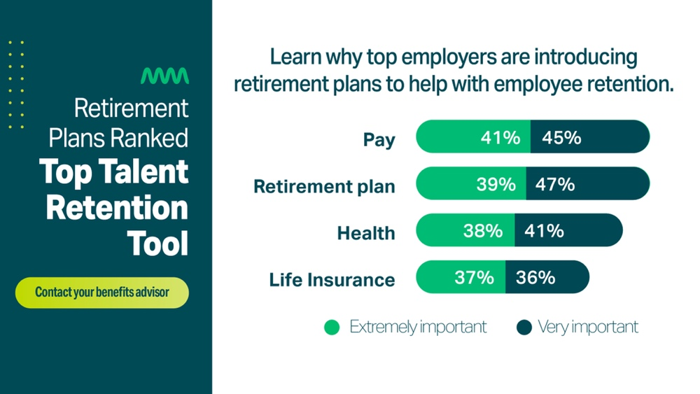

A great retirement plan doesn’t have to be expensive or complicated. [Brokerage name] has partnered with Common Wealth to provide an award-winning, digital group RRSP/TFSA built for growing businesses.

I’d love to set up a time to discuss further.

Regards,

[advisor name]

Reward

Subject: The top benefit according to employees

Hello [sponsor name],

Financial security is top of mind for Canadians. Most people are concerned about having enough money in retirement and are willing to forgo a bump in pay for a retirement plan.
With the current labour shortage, employees have more job opportunities than ever. That’s why strategic employers are introducing retirement benefits.

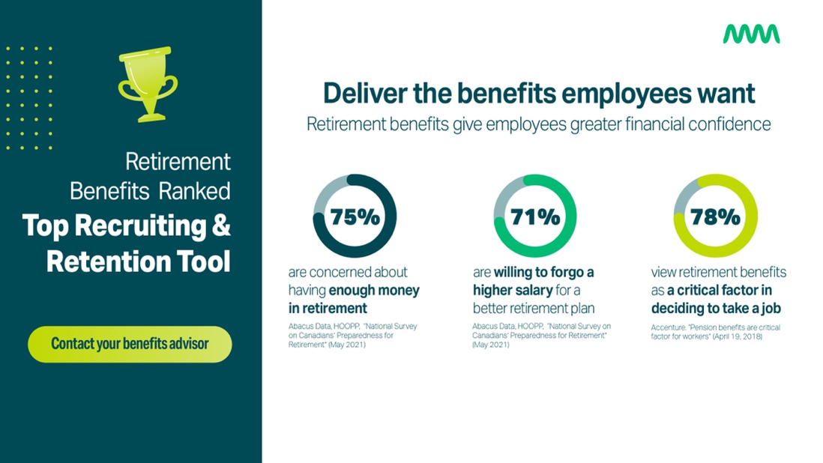

A great retirement plan doesn’t have to be expensive or complicated. [Brokerage name] has partnered with Common Wealth to provide an award-winning, digital group RRSP/TFSA built for growing businesses.

I’d love to set up a time to discuss further.

Regards,

[advisor name]

